**Studio in Art with Ms. Campbell**

**Assignment #3: Found Object Color Wheel**

Using objects that you find around your home, you are going to create a color wheel.

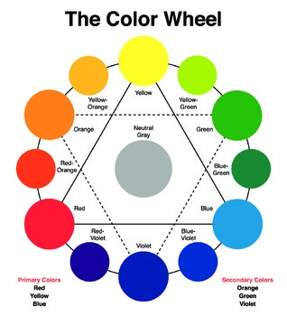

**STEP 1-**You need **5 objects in each color** - Red, Orange, Yellow, Green, Blue, Violet.

Some ideas: Choose objects that fit your personality! You can have a theme. Make it fun and get creative.

**STEP 2-**Once you’ve collected your objects, arrange them in a wheel.

They need to be arranged in the correct color order! Red, Orange, Yellow, Green, Blue, Violet.

**STEP 4-** Write a brief reflection. How did you begin? Explain the process of creating this work.

What obstacles or problems did you run into while working on this assignment?

**STEP 3-** Take a photo of your color wheel and send to [NCampbell@nfschools.net](mailto:NCampbell@nfschools.net)

*TIP- get the camera phone right over top of your color wheel to take the photo.**

If you google **“Found Object Color Wheel”** or look at *#foundobjectcolorwheel* on Instagram, you will find lots of examples.

**TIPS:**

* Find at least 5 objects for each color.
* After you arrange your wheel, take a step back and make sure it looks the way you’d like it to.
* Add more objects if one color seems small.
* Have fun and choose things that show off who you are!
* You can place a small object the center that your wheel that your color items can “point to”…Then remove it for your picture. Because it’s difficult to get your items to point to one spot. (if that is what you are going for)

**Grades**

* *If you send a correct color wheel with at least 5 objects in each section, and a summary, you will get a “P” for Pass.
* *To get an “M” for mastery (over 90%) you will need to choose objects that fit your personality or have a theme, or have then arranged uniquely. This is an easy lesson…I have no doubt that you can think of a way to go beyond the minimal expectations while still having fun with it!
* * If you do not do the assignment you get a 0 or “F”, for fail.

******BE SURE TO INCLUDE YOUR FIRST AND LAST NAME IN THE EMAIL

GOOD EXAMPLES:

 